Geometry: Unit 9, Lesson 9

- What solid has a net comprised of four congruent triangles?

Triangular Pyramid

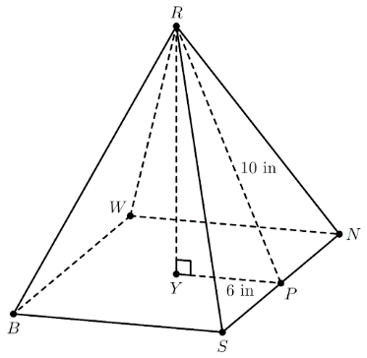
- A square pyramid with base $BSNW$ and vertex $R$ is shown where $RP=10$inches $(in.)$ and $YP=6 in.$ What is the height, $RY$, of the square pyramid?

$8.0 in$

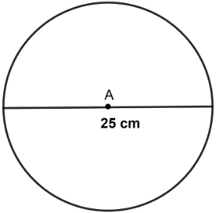
- What is the area of the given circle?

$$490.63 cm^{2}$$

